


June 2019

Throughout Scripture, Jesus uses family terminology to describe our relationship with him and with other Christians. He calls his followers children of God and his beloved brothers and sisters.

Because families are so important to Jesus, he offers instructions for how loved ones should live: “Forgive your brothers and sisters from your heart” (Matthew 18:35) and “Love each other with genuine affection, and take delight in honoring each other” (Romans 12:10).

Family is one of our most special blessings from God, yet maintaining God-honoring relationships with family members can be challenging at times. Squabbles may turn into blowups, often involving unkind words and leading to hurt feelings. Jesus’ earthly life and ministry provide great examples of how we are to treat family members. Jesus showed us the importance of humility, servanthood, honesty, kindness, and peacemaking. He also emphasized that no one—not even our family members—should be more important to us than God is.

Jesus nurtured others through compassion and invested deeply in people who later changed the world. Our homes can be places where children are turned on to faith through the power of loving relationships with family members of all ages.

The next page is filled with fun, meaningful activities you can try with your own family.

Faith-Building as a Family of God


POWERSOURCE
ASK JESUS:
1. To help your family make Jesus its top priority.
2. To remind your family members to demonstrate Jesus’ love to one another.
3. To continually grow the faith of each of your family members.

Church Logo and
Information
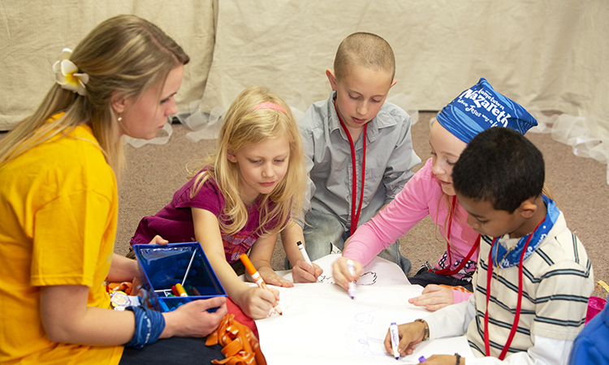
TEACHABLE
MOMENTS

Positivity Posters

You’ll need poster board, sticky notes, and markers. Have family members each write their name atop a sheet of poster board. Hand out sticky notes, and have people write on each note two things they like about themselves. Have them stick those to their poster.

Say: Identifying good things about ourselves is pretty easy. Now take a sticky note for each family member, write at least one positive thing about each person, and place the note on their poster. It might be a talent, a personality trait, or even someone’s smile. Allow time for writing notes and reading posters.

Read aloud 1 Thessalonians 5:11. Ask: What’s different about what you wrote about yourself and what others wrote about you? How does it feel to know what family members think of you? What does the combination of all these positive things say about our family? about our family’s potential to make a difference in this world for Jesus?
Close in prayer.

We Are Family!

God calls parents to the role of primary faith influencer for their children, so the Christian home is the epicenter for spiritual growth. Ephesians 6:4 says, “Bring [your children] up with the discipline and instruction that comes from the Lord.” Yet the final goal isn’t a generation of well-trained children; if your kids stand beside you in heaven, they won’t do so as your children but as your sisters and brothers in God’s family. That’s why sharing and living out the gospel at home is just the beginning. The goal is for God’s love and truth to be revealed to all people so they, too, can join God’s family.

We know what real love is because Jesus gave up his life for us. So, we also ought to give up our lives for our brothers and sisters.
—1 John 3:16

Some More Kindness Make s’mores (outside, if possible). While enjoying the snack, share times you’ve done “some more”—a kind act—for someone, or how a person reached out to do “some more” for you. Read aloud Galatians 5:13-14. Ask: “Why does God want us to do some more for others? What might that look like in our home?”
A Winning Attitude Play Tug-of-War or arm wrestle. Ask: “What are some ways we compete with family members?” Read aloud Genesis 4:1-12. Ask: “What feelings did Cain and Abel have toward God? toward each other? How could Cain have handled his anger better? How can we handle anger toward family members?”

A-Mazing Focus On the back of eight paper plates, lightly write “no.” On the back of eight more, write “yes.” Mix up plates and place them writing-side down in a 4X4 grid on the floor. Take turns trying to go through the maze by flipping over a plate. If it’s a yes, step on it and try to find another yes. If it’s a no, go back to the end of the line and turn all the plates back over. You can give each other non-verbal clues to achieve the goal. Find all eight yes plates so others can step on them in the same pattern to finally get through the maze. Read Philippians 3:17. Ask: “Why was teamwork so important for this task? What are ways we can help each other find—and stay on—the right path to follow God?”

Ultra Strong For each person, you’ll need a six-foot strip of toilet paper. Sit in a circle and quickly weave the strips over and under each other to form a rug. Make sure it’s sturdy by gently waving it in the air. Time the task and then try again, even faster. Afterward, ask: “How was working on this rug like being part of a family? What can tear a family apart? What makes a family strong?” Read aloud Ephesians 3:14-16. Pray, asking God to give strength to individual family members and to your family as a unit.

Super & Soaked Outside, make a shaving cream “hat” on someone (or on an inflated balloon). Take turns using a water-filled spray bottle to squirt away the foam. Before each turn, the sprayer must say one instruction or advice they’ve heard from a parent. Afterward, read aloud Proverbs 1:8. Ask: “Why does God want us to listen to our parents? What can make that easy or hard to do? What instructions does God give us? Why is it important to obey those?”



MOVIE

Title: Toy Story 4
Genre: Animation, Adventure, Comedy
Rating: G
Cast: Tom Hanks, Tim Allen, Christina Hendricks, Patricia Arquette
Synopsis: Bonnie, the toys’ new owner, creates Forky, a spork craft who has angst about what it means to be a toy. On a road trip, the group finds Bo Peep and some other toys in an antique shop. Together they discover their purpose for existing.
Our Take: The latest installment in this Pixar series, beloved by parents as well as children, is reportedly another tearjerker. After seeing the movie, families can have age-appropriate discussions about why God made us, what our purpose is, and how family members and friends stick together.

MUSIC

Artist: Billie Eilish
Album: When We All Fall Asleep, Where Do We Go?
Synopsis: Eilish, 17, is the first singer born in the 2000s to hit #1 on the Billboard Hot 100 chart. Her “don’t care” attitude and grungy look is wildly popular with young listeners. The singer, who admits she’s “kind of scary,” has been open about having Tourette’s syndrome.
Our Take: Be warned: Eilish’s songs and videos are packed with dark imagery, violence, references to sex, and intense emotions. Her husky sound is “all wrapped up in existential pain,” says one reviewer. In the melody “Bury a Friend,” Eilish sings, “I wanna end me.” Needless to say, her songs are not kid-friendly or positive in any way for kids.

MEDIA MADNESS

CULTURE
& TRENDS
Role Requests More new parents are planning elaborate godparent proposals, turning the request into a social-media-worthy moment. Customized products abound for fun ways to make the big “ask”—regardless of religious belief. (various sources)

ASMR Stars Kids are achieving online fame for more than just singing and applying makeup. Some post videos of oddly relaxing sounds, known as ASMR (autonomous sensory meridian response). Makenna Kelly, age 13, has 1.5 million subscribers who watch her tap, whisper, and eat. (YouTube)

QUICK STATS
What Free Time? The average U.S. adult has just four hours and 26 minutes of free time per week. Forty percent of people say they have even less than that. (H&R Block)

Mental Health Stats From 2007 to 2015, depression- and suicide-related ER visits by U.S. kids and teens doubled, to 1.12 million. Forty-three percent of the visits were by kids ages 5 to 11. (JAMA Pediatrics)

Podcasts on the Rise Last year, an estimated 48 million Americans listened to podcasts weekly. (edisonresearch.com)

Games, Podcasts & Apps

American Ninja Warrior Challenge
In this game, available for various consoles, players create and train athletes to complete virtual obstacle courses. You also can create your own courses. The game is rated E for Everyone, but skill is required. In-game purchases abound.

Short & Curly
Kid-friendly discussions about ethics take center stage on this fast-paced podcast. Recent topics include whether it’s okay to eat pets and whether birthday gifts should be a thing of the past. Kids ages 8+ will enjoy these philosophical debates about issues that are important to them.

Smash Your Food
Using a fun approach, this app helps kids think about what they put in their mouth. After guessing the salt, sugar, and fat content of a food, users pull a “smash lever” for the results. The app, which also provides helpful charts, can serve as a helpful conversation starter for families.

This page is designed to help educate parents and isn’t meant to endorse any movie, music, or product. Our prayer is that you’ll make informed decisions about what your children watch, read, listen to, and play.

June

SUNDAY | MONDAY | TUESDAY | WEDNESDAY | THURSDAY | FRIDAY | SATURDAY
 |  |  |  |  |  | 1
2 | 3 | 4 | 5 | 6 | 7 | 8
9 | 10 | 11 | 12 | 13 | 14 | 15
16  Father’s Day | 17 | 18 | 19 | 20 | 21  First Day of Summer | 22
23 | 24 | 25 | 26 | 27 | 28 | 29
30

[Photo box]
[Title]

[Text]

[Title]
[Text]

[Text]
[Text]

[Photo]
[Text]

[Title]

[Text and Photos]
[Text and Photos]
[Title]
[Text]
[Photo box]
[Title]
[Text]

[Title]
[Text]

