
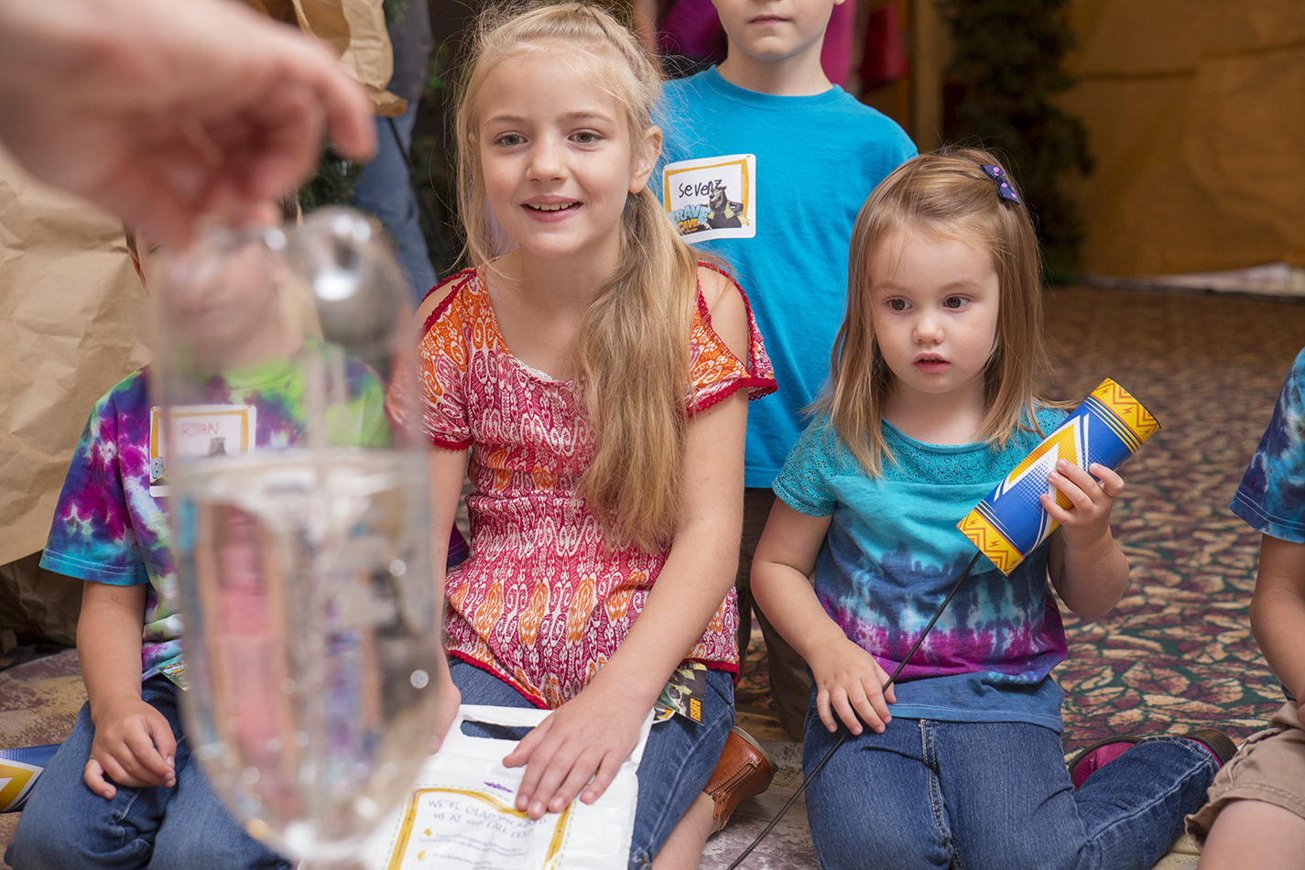

September 2019

With a new school year on the horizon, attention turns to goals for learning and growing. To encourage academic improvement, many schools now emphasize what psychologist Carol Dweck calls the “growth mindset”—a belief that anyone can learn and grow with effort. Potential is unlocked when children believe they can learn from challenges and by working hard.

By contrast, a “fixed mindset” is a belief that one’s basic abilities and talents are predetermined. These kids (and adults) aren’t interested in learning how to improve because they don’t believe they can.

Dweck’s approach is relevant beyond the classroom; in fact, it applies to faith growth, to some degree. People with a fixed mindset believe they’re bad and can’t change, that imperfections are shameful, and that if they face challenges, something must be wrong with their faith.

Those with a growth mindset, however, realize it’s okay to share their sins and struggles with others. They know that Jesus loves and forgives them no matter what, and they believe they can grow closer to Jesus by trusting him during life’s inevitable challenges.

One thing we do want to be fixed in kids’ minds is their innate, God-given value. God made us in his image and wants to be in relationship with us despite our shortcomings. Because we don’t have to prove our worth to God, we can focus instead on growing closer to him.

It’s Time to Get Growing!


POWERSOURCE
ASK JESUS:
1. To guide your children toward growth in all areas this year.
2. To help you model a growth mindset, especially regarding faith in Jesus.
3. To teach you to depend on God during the upcoming school year.

Church Logo and
Information

TEACHABLE
MOMENTS

Breakthrough!
You’ll need see-through glass or plastic containers filled with water, foaming shaving cream, and blue and yellow food coloring. Say: Sometimes life seems cloudy. Have family members each squirt a layer of shaving cream over the water. Ask: When have you felt stuck or been discouraged?
As people share, have them add a few drops of food coloring over the “clouds.” Say: When we face tough things, God is with us and encourages us.
Read aloud Isaiah 41:10 and Joshua 1:9. Watch as the food coloring breaks through the shaving cream, creating streaks of color in the water. Ask: How is this experiment like life? How can challenges result in something good or positive?
Read aloud Romans 8:28. Ask: What are ways you can trust God during both good and tough times? Pray, thanking God for always loving and helping us.

Positive Ways to Grow

Instilling a faith-growth mindset can be as simple as altering the praise and feedback you give your children. Follow these guidelines:
- Let kids know God already loves them—no matter what.
- Say the goal is to be best friends with God, not to appear good.
- Praise kids for the effort they put into resisting a temptation.
- Praise kids for getting to know God, not just knowing about him.
- Encourage kids to ask Jesus for help when they’re struggling.
- Encourage kids to share their failures with trusted friends and adults.

“We are surrounded by a great cloud of people whose lives tell us what faith means. So let us run the race that is before us and never give up.”
—Hebrews 12:1, NCV

Pressing On Gather origami paper, Glue Dots, and scissors. Download craft instructions from childrensministry.com/origami-star and make a sample ahead of time. Show family members the star and have them make their own. Offer encouragement and help, as needed. Read Philippians 3:12-15 and say: “Paul loved Jesus but still messed up. He pressed on, just as you did with this craft.” Ask: “How can these verses help you press on, even when you mess up?”
Take Aim! For this outdoor game, divide a rectangular area in half. Play “volleyball” with an inflated balloon and squirt guns. Players can use unlimited squirts to move the “ball.” Afterward, ask: “What was this game’s goal? How did we work to reach it? What are some goals you have? Who helps you reach them?” Read Psalm 16:7-8. Say: “God instructs you and goes before you as you aim for goals!”

Growth Takes Time Fill clean baby food jars halfway with heavy cream. (You can add a marble, but use caution.) Secure the lids. Ask: “Does this look like butter? Do you think you can make it into butter?” Say: “Shake a jar while we talk.” Read Matthew 17:14-20. Ask: “How much faith does it take to do the impossible? What tough thing do you need God’s help with?” Shake jars a few more minutes, until butter forms. Enjoy some on bread. Then discuss how it can take time to see God’s miracles—and how we shouldn’t give up!

Forward in Faith Clear obstacles from a room that can be darkened. Have one person stand as a lighthouse who whispers “Trust in the Lord” repeatedly. Lead everyone else into the room—with eyes closed. Say: “You have one minute to reach the lighthouse. When you do, open your eyes, lock arms, and join in the whispering.” Play several rounds. Then ask: “How did it feel to find the lighthouse? How did it feel when time ran out?” Read aloud Proverbs 3:5-6. Say: “Let’s trust God as we walk and grow in faith.”

Ch-Ch-Changes Stand in a circle with hands behind backs. Have “It” stand in the center with eyes closed as you place a Bible in someone’s hands. Have It open his or her eyes as people pass the Bible behind their backs. Whoever holds the Bible must briefly change his or her facial expression. It guesses who has the Bible, and if correct, that person becomes the new It. Read aloud Mark 4:3-20. Discuss how the Bible changes us and makes us more like Jesus.

xx xx

xx xx

xx xx



MOVIE

Title: Overcomer
Genre: Faith-based drama
Rating: PG (some thematic elements)
Cast: Alex Kendrick, Priscilla C. Shirer, Aryn Wright-Thompson
Synopsis: A plant closure in town leads to changes for many people, including a high school coach who must switch sports. When the only runner who shows up for his cross-country team is a girl with asthma, they’re both challenged to discover their new and true identities.
Our Take: This life-affirming film encourages viewers to “go the extra mile” for one another and to give Jesus first place in their hearts. It emphasizes that one’s identity in Jesus matters most and that people who follow Jesus are to live out their faith daily.

TV

Title: Molly of Denali
Network: PBS Kids
Synopsis: The star of this new animated series is a 10-year-old Native Alaskan girl, voiced by a young indigenous actress. Molly’s adventures help her learn about the 49th state’s people and history. She uses the Internet and in-person interviews to discover what life was like for her ancestors. She also makes connections between their interests and her own.
Our Take: While exposing children to cultural diversity, this show encourages them to be curious about their own heritage. The episodes can serve as springboards for age-appropriate discussions (and research) about your family’s history, stories, and traditions.

MEDIA MADNESS

CULTURE
& TRENDS
Earlier Puberty: It’s Not Just for Girls According to a new study, more boys are now reaching puberty earlier—and one factor may be higher BMI (body mass index). Though the study has limitations, it points to another possible effect of America’s obesity epidemic. (JAMA Pediatrics)

Catching the Vision To help kids set and focus on goals, some teachers and parents now use back-to-school vision boards. Assembling a collage of photos to represent reachable goals can be an effective way to develop grit—especially for visual learners. (various sources)

QUICK STATS
Every Day We’re Hustlin’ Almost half (48%) of parents of kids under 18 have a side job, working an extra 13 hours per week. And 27% of those with a side hustle say they’re more passionate about it than they are about their regular job. (bankrate.com)

Stuffed! Although only 3% of the world’s children live in the United States, they own about 40% of the toys purchased globally. Perhaps that’s why one in 10 Americans rents off-site storage—at the average cost of $400 yearly. (uctv.tv; nytimes.com)

Games, Podcasts & Apps

Cadence of Hyrule
In this rhythm-based “Zelda” spinoff for the Nintendo Switch, players must step (and fight) to the beat to progress through puzzle dungeons. The goal is to collect foes that look like musical instruments in order to defeat the enemy Octavo. Combat is cartoonish in this E-rated game.
Chompers
Kids will look forward to brushing their teeth thanks to this twice-daily podcast. Each episode features two minutes of jokes, stories, fun facts, and silly songs. Weekly themes range from dinosaurs and robots to cooking and interviews. Chompers, geared toward ages 3 to 7, also is available on Alexa.
Superbook Kids Bible
This free Bible app for young readers brings God’s Word to life with the addition of videos, images, and interactive games. It also includes 26 episodes of the Superbook series, as well as “Superstreaks” that encourage readers to regularly engage with the biblical text.

This page is designed to help educate parents and isn’t meant to endorse any movie, music, or product. Our prayer is that you’ll make informed decisions about what your children watch, read, listen to, and play.

September

SUNDAY | MONDAY | TUESDAY | WEDNESDAY | THURSDAY | FRIDAY | SATURDAY
1 | 2  Labor Day | 3 | 4 | 5 | 6 | 7
8  Grandparents Day | 9 | 10 | 11  Patriot Day | 12 | 13 | 14
15 | 16 | 17 | 18 | 19 | 20 | 21
22 | 23 | 24 | 25 | 26 | 27 | 28
29 | 30

[Photo box]
[Title]

[Text]

[Title]
[Text]

[Text]
[Text]

[Photo]
[Text]

[Title]

[Text and Photos]
[Text and Photos]
[Title]
[Text]
[Photo box]
[Title]
[Text]

[Title]
[Text]

