


May 2019

Death is a tough topic, especially for children. It’s challenging to explain why people die and what happens to them after they die. Some kids have little experience with death, while others may have had their world turned upside-down by a loved one’s passing.

Death is sin’s ultimate “sting,” but for Christians, Jesus has erased it. By rising from the grave, Jesus “gives us victory over sin and death” (1 Corinthians 15:55-57). Jesus promises to “prepare a place” for us in heaven, saying, “There is more than enough room in my Father’s home” (John 14:2).

The concepts of heaven, hell, and eternity are too abstract for younger children to understand, but we can assure them we’ll always be with Jesus in a place with no sadness or pain. As kids grow older, we can let them know Jesus is the only way to heaven—and any teachings about different paths to eternal life are false. Jesus says, “I am the way, the truth, and the life. No one can come to the Father except through me” (John 14:6).

During life’s trials and challenges, followers of Jesus can find comfort in the sure hope of heaven. Yet we don’t need to wait until we arrive there to experience Jesus’ presence and peace! He promises to be with us “always” (Matthew 28:20)—a message that children and adults of all ages need to hear often.

Use the ideas on the next page to celebrate Jesus’ promise of heaven.

Jesus Is the Way to Heaven


POWERSOURCE
PRAY TO JESUS:
1. Thank Jesus for dying on the cross and for rising from the tomb to forgive and save us.
2. Ask Jesus to remind your family members of his love and his promise of heaven.
3. Ask Jesus to help you tell others about him—and about heaven.

Church Logo and
Information

TEACHABLE
MOMENTS

Postcard Perfect
You’ll need a Bible, postcards or pictures from vacations, pencils, and blank card stock cut in postcard shapes. Look through postcards together and discuss favorite vacation memories.
Say: These places are beautiful, but I know of an even better place. It has streets of gold, no tears or pain, and no night. Ask: Do you know what this place is? Have you ever received a postcard from heaven? Say: No, me neither. But someone who went there has given us a special gift!
Read aloud Acts 1:8-11. Say: When Jesus went back to heaven, he didn’t send a postcard; he sent the Holy Spirit. The Spirit helps us believe in Jesus so we can go to heaven.
Hand out pencils and card stock. Say: On one side of the postcard, write or draw a thank-you to Jesus for sending the Holy Spirit. On the other side, draw a picture of what you think heaven is like. Close in prayer.

We Have the Hope of Heaven

Until children are about 5 or 6, it’s best to talk about heaven as a place where they can live someday. Don’t try to explain the spiritual or abstract aspects of heaven yet. As children grow, they’ll begin asking more questions—especially why people go to heaven or hell when they die. If you don’t have all the answers, be honest and research what the Bible says. Explain that Jesus wants everyone to live with him forever, and remind kids that people’s actions don’t send them to heaven or hell. Believing in Jesus is the only way to heaven, and it’s his free gift to us.

“For this is how God loved the world: He gave his one and only Son, so that everyone who believes in him will not perish but have eternal life.”
—John 3:16

A Special Place Say: When we’re friends with Jesus, we’ll go to heaven someday. The Bible says heaven is amazing. Have family members use modeling dough to create shapes of what they imagine heaven will be like. Say: Matthew 6:20 says we’ll have treasures in heaven. John 14:2 says heaven has rooms for many people. Revelation 19:1 says people in heaven shout praises to God. Revelation 21:3-4 says God lives with us in heaven and wipes away our tears. There’s no more sadness or death in heaven. It’s our forever home with God.
Transformed When you see butterflies, discuss their lifecycle and how that symbolizes our rebirth in Jesus. Say: After a caterpillar spins a cocoon, it begins a new life as a beautiful butterfly. Someday we’ll die, but when we believe in Jesus, he gives us a beautiful new life in heaven. We’ll be happy and free forever! Draw or make butterflies as reminders of new life in Jesus.

Headed to Heaven Place a variety of small items on a tray. Say: Look at these items and try to remember them all. Have family members close their eyes while you remove one item. Then have them guess what’s missing. Play several rounds. Read aloud Acts 1:8-11. Ask: How hard was this game? What do you think about how Jesus disappeared in the clouds? Why do you think Jesus returned to heaven? Say: Jesus is preparing a place for us in heaven, but he’s still with us today, in our hearts. Jesus is never missing.
A Work of Heart On Memorial Day (or when there’s a death in your family), make a reminder of people who’ve gone to heaven. Decorate paper squares, listing one person or group (such as soldiers) on each square. Tape squares to form a remembrance quilt. Say: When people die, we miss them. The Bible tells us a reason to not feel so sad. Read John 3:16. Say: If we believe in Jesus, we’ll go to heaven. What do you think we’ll do there? Pray, thanking God for people who’ve already gone to heaven.
Crown Jewels Make crowns out of construction paper and craft gems. Read aloud Revelation 21:10-11, 18-23. Ask: Why do you think heaven is filled with gold, precious gems, bright light, and no darkness? Read Revelation 2:10. Say: We’re children of Jesus the King; we’re his heirs. That means we’ll live in his kingdom of heaven.

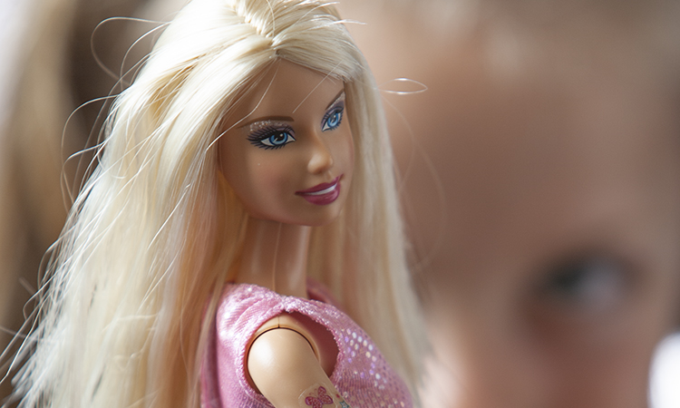
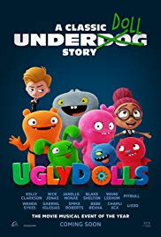
MOVIE

Title: UglyDolls
Genre: Animated musical comedy
Rating: Not yet rated
Cast: Emma Roberts, Kelly Clarkson, Nick Jonas, Janelle Monáe
Synopsis: Free-spirited misfit dolls are each searching for an ideal human match. They leave UglyVille for the Institute of Perfection, where beauty and conformity are prized. Moxy, the group’s leader, helps the UglyDolls feel good about being exactly who they are—flaws and all.
Our Take: As a kid-friendly parable, this movie champions the value of individuality. Parents can add a biblical perspective, emphasizing that God makes us each different and special. Encourage kids to be proud of their unique traits and talents.

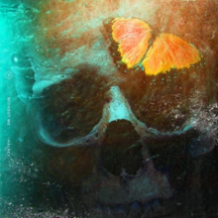
MUSIC

Artist: Halsey
Synopsis: Singer-songwriter Halsey rose to fame via Tumblr and has built a following for the past five years. Now 24, Halsey has gone mainstream, often appearing on TV and awards shows and ever-present on kids’ playlists. Her single “Without Me” was a chart-topper, and she’s working on her third album. Halsey’s lyrics and videos are often dark and sexually explicit, featuring violent imagery and alcohol use.
Our Take: Halsey has bipolar disorder and advocates for suicide prevention, which is admirable. She’s also vocal about her bisexuality and struggles as a homeless teenager. The mature content in her lyrics and videos isn’t a positive influence or appropriate for kids.

MEDIA MADNESS

CULTURE
& TRENDS

Dolls With Disabilities The 2019 line of Barbie dolls, out in June, includes a doll with a prosthetic limb and one with a wheelchair (plus a ramp for the Barbie Dream House). Mattel consulted a 13-year-old disability activist and medical experts for advice. Also debuting are dolls with “a new body type and braided hair texture.” (disabilityscoop.com)

Walk & Talk Therapy A new mode of counseling is ideal for stroller-pushing parents. Some therapists now offer “on the go” sessions, walking alongside parents who either lack child-care or prefer to stay with their kids. Counselors say people tend to open up more while walking side by side, when eye contact isn’t required. Plus, exercise releases mood-boosting endorphins. (cnn.com)

QUICK STATS
Sorry, Young Chefs Only 4% of moms say they want breakfast in bed for Mother’s Day. Instead, make reservations! Almost 40% of moms prefer brunch at a restaurant. (Zagat)

Rats! In a survey, people who owned rats when they were 17 or younger say they were happier with those pets than with others such as cats and dogs. (rightpet.com)

Games, Podcasts & Apps

Candygrams
This colorful anagram board game for two to four players involves luck and strategy. It’s like a child-friendly Scrabble hybrid, with color-coding thrown into the mix. Candygrams helps kids develop word skills and can be played at different paces. It costs $24.99 and is designed for ages 7+.
Pants on Fire
In this silly game show, listeners become lie-detectors to decide which of two “experts” is real. On each episode, a child interviews two people to determine who knows their stuff and whose pants are on fire from lying. The podcast, geared toward preteens, teaches kids to be good question-askers.
Kanopy Kids
To access the content available through this app, all you need is a library card. The kids’ section is filled with a wide variety of animated books, educational videos, and TV series. Parents should oversee usage, though, making sure young users stay only in the Kanopy Kids section.

This page is designed to help educate parents and isn’t meant to endorse any movie, music, or product. Our prayer is that you’ll make informed decisions about what your children watch, read, listen to, and play.

May

SUNDAY | MONDAY | TUESDAY | WEDNESDAY | THURSDAY | FRIDAY | SATURDAY
 |  |  | 1 | 2 | 3 | 4
5 | 6 | 7 | 8 | 9 | 10 | 11
12  Mother’s Day | 13 | 14 | 15 | 16 | 17 | 18
19 | 20 | 21 | 22 | 23 | 24 | 25
26 | 27  Memorial Day | 28 | 29 | 30 | 31

[Photo box]
[Title]

[Text]

[Title]
[Text]

[Text]
[Text]

[Photo]
[Text]

[Title]

[Text and Photos]
[Text and Photos]
[Title]
[Text]
[Photo box]
[Title]
[Text]

[Title]
[Text]

